**BY: Sirajuddin Khan Roll No: CB.SC.P2CSE23011**

**Kidney Disease Classification(Normal, Tumor or Stone presence in Kidney)**

**System Design**:

* **Create and maintain the project environment:** This pipeline will set up the necessary tools and libraries that are needed to run the project.
* **Data Acquisition & Preprocessing:**

1. **CT Scan Images:** Represents your CT scan image dataset (DICOM format possible).
2. **Dicom Conversion:** Convert DICOM format images to a common format like PNG or JPEG if needed.
3. **Data Cleaning & Augmentation:** Address missing values, reduce noise, and apply augmentation techniques (rotations, flips) to enrich data.
4. **Feature Engineering:** Extract relevant features like intensity, texture, and anatomical characteristics using image processing or pre-trained layers.
5. **DVC:** Version control code and data for reproducibility and traceability.

* **Model Training & Experimentation:**

1. **MLflow Tracking:** Track training runs, hyperparameter configurations, and evaluation metrics with MLflow for experiment logging and comparison.
2. **Model Training:** Train various models (e.g., CNNs, LSTMs) on preprocessed data, utilizing DVC for managing different versions and dependencies.
3. **Hyperparameter Tuning:** Optimize hyperparameters (learning rate, batch size) to improve model performance.
4. **Model Evaluation:** Evaluate models using AUC-ROC, accuracy, and other relevant metrics for both classification and regression tasks.
5. **Model Selection:** Choose the best-performing model based on evaluation results and interpretability considerations.

* **Deployment & Monitoring:**

1. **Model Serving:** Deploy the selected model to a production environment for real-time predictions.
2. **API Integration:** Develop an API to enable seamless integration with other healthcare systems or user applications.
3. **Model Monitoring:** Track model performance over time using MLflow, logging metrics for potential drift or degradation.

* **User Application:** Designing an interface for patients or professionals to upload CT scans and receive predictions, and visualize results.

**SYSTEM ARCHITECTURE FOR BOTH WEB AND MOBILE APP**

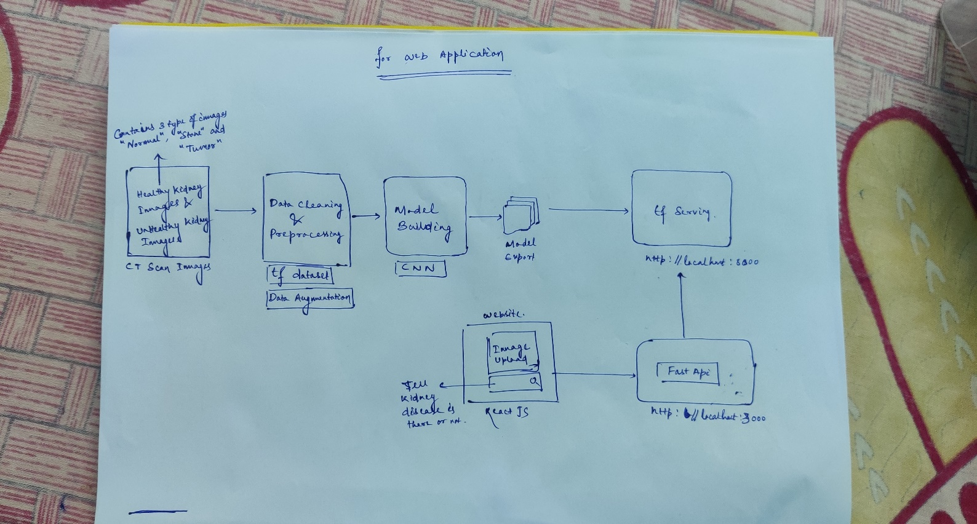

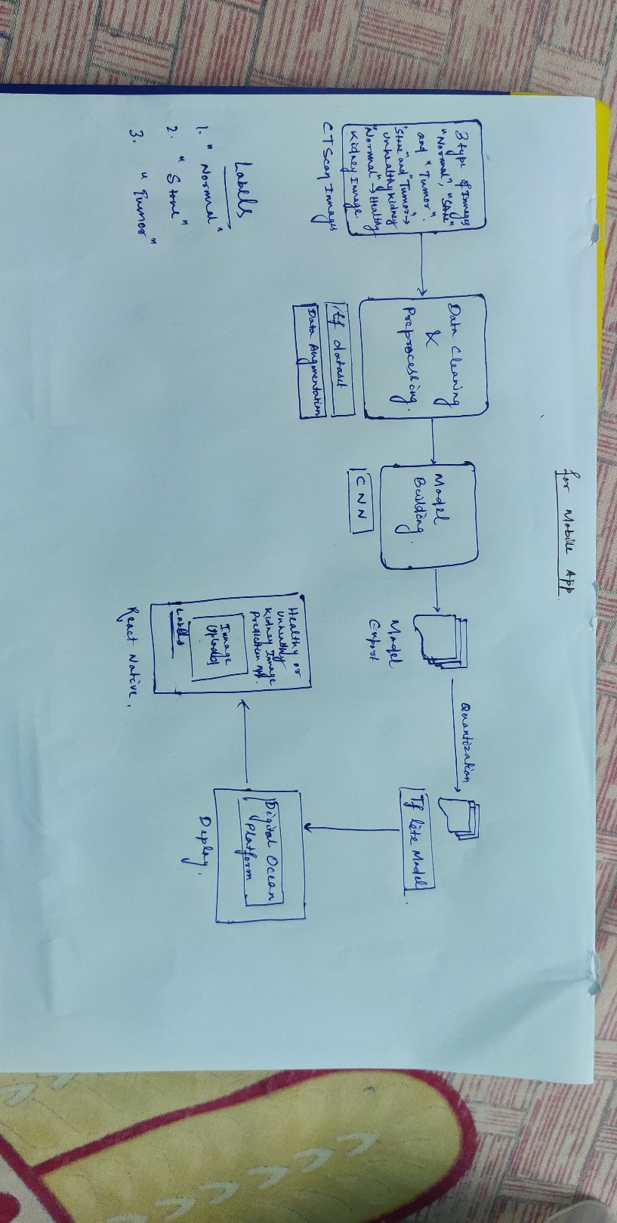

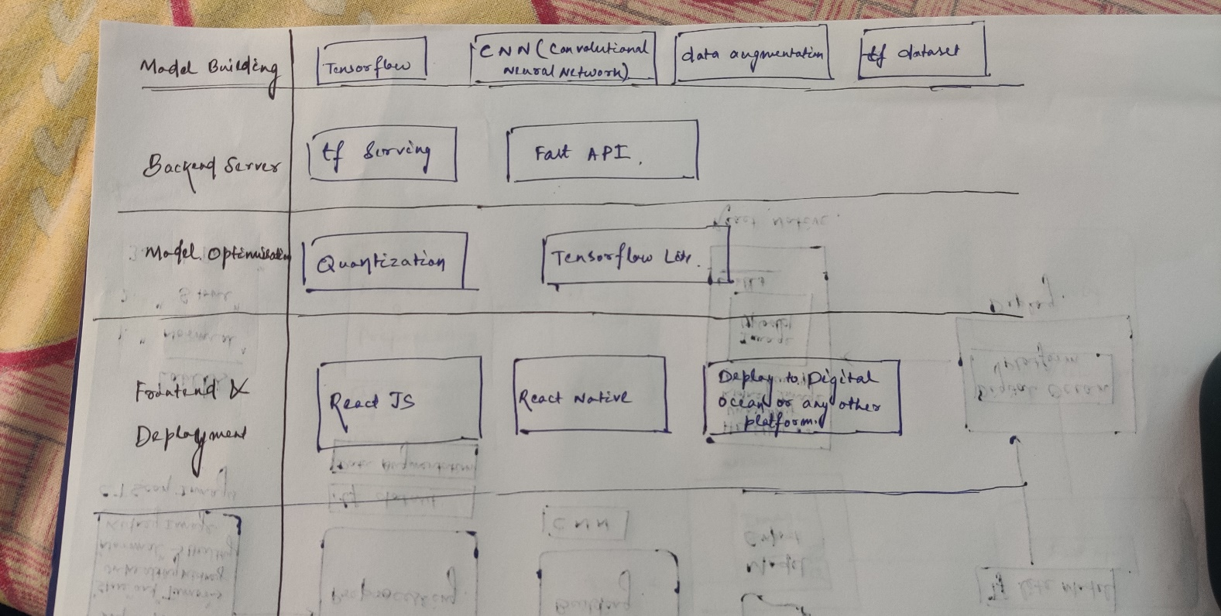

**User Aspects:** We can design an interface for patients or professionals to upload CT scans and receive predictions, and visualize results.

* **Primary Use Case:** Upload CT scan images and receive a risk assessment for kidney disease.
* **Desired Functionalities:**
  + Simple and intuitive interface for uploading medical images.
  + Clear and concise presentation of results, including predicted risk score and probability.
  + Data privacy and security assurances.
  + Configurable options for displaying and interpreting model predictions.
  + Ability to export data and results for further analysis or reporting.
  + Clearly communicate the limitations and accuracy of the model predictions.
* **Accessibility needs:** Consider language support, disability-friendly interface elements, and alternative output formats if needed.
* **Emotional considerations:** Acknowledge the sensitive nature of the information and provide support resources for potential anxiety or concerns.

